APPLECROSS SENIOR HIGH SCHOOL

YEAR 11 HUMAN BIOLOGY

TEST 1

DO NOT MARK THIS PAPER IS ANY WAY

Time allowed: 40 minutes Total marks: /40

PART A: Multiple Choice (20 marks)

- Mitochondria concentration would be highest in which of these cells?

- Nerve cells
- Secretory cells
- Muscle cells
- Red blood cells

- The energy from cellular respiration is trapped and stored in the form of:

- Glucose
- DNA
- ATP
- ADP

- When viewing cells under the microscope, which of the following is false?

- The higher the magnification, the less cells you see
- When the slide is moved to the right, it appears to move to the left
- Under lower magnification you would see more of the cells in the field of view
- When changing the magnification from 40X to 100X, the field of view is greater

- A series of interconnecting canals transporting fluids has been observed in the cell. These canals are called:

- Mitochondria
- Endoplasmic reticulum
- Centrioles
- Lysosomes

- If a mixture of proteins and glucose is placed in a cellulose bag immersed in water, the glucose will diffuse through the bag but the proteins will not. This is because the bag is:

- A living membrane
- Selectively permeable
- Permeable only to molecule of inorganic origin
- Impermeable to all except large organic molecules

- The concentration gradient of lactic acid in a muscle is found to be greater after exercise than before. The reason for this is:

- Insufficient oxygen in the muscle
- An excess of carbon dioxide in the muscle
- Insufficient glucose in the muscle
- A high rate of aerobic respiration

- More energy is made available in aerobic respiration than anaerobic respiration because:

- Oxygen from the air supplies some energy
- Aerobic respiration in an energy-releasing reaction, whereas anaerobic respiration is a reaction requiring energy
- Lactic acid production in anaerobic respiration contains chemical energy which may be released by further reaction
- More energy is lost as heat in anaerobic respiration

- The compound in which energy from cellular respiration is stored is essential to every living cell because it:

- Speeds up breakdown of glucose in the cell
- Provides energy for secretion of substances from the cell
- Can diffuse out of the cell
- Stored energy in a form which is instantly available

- Which of the following statements about cells and surface area are correct?

- Increasing the diameter of a cell increases the surface area more than the volume
- Increasing the diameter of a cell increases the volume more than the surface area
- Increasing the diameter of a cell increases the volume but decreases the surface area
- Increasing the diameter of a cell increases its surface area but decreases its volume

- Which of the following is the best definition of osmosis?

- Movement of molecules from regions of high concentration to regions of low concentration
- Movement of molecules from regions of low concentration to regions of high concentration
- Net movement of water molecules across a differentially permeable membrane
- Random movement of molecules or ions in solution

- All cells obtain energy for their general activity by the oxidation of glucose. This process is known as:

- Reproduction
- Respiration
- Photosynthesis
- Metabolism

- The concentration of a particular ion within a cell is higher than the concentration outside the cell. However, the concentration in the cell is still increasing. This is due to:

- Osmosis
- Diffusion
- Active transport
- Facilitated diffusion

- Four microscopes were set up in the laboratory as follows:

Microscope | Objective Lens | Ocular
A | 10X | 5X
B | 20X | 10X
C | 40X | 5X
D | 40X | 10X

When looking at a slide of human tissue, which microscope would you expect to observe the fewest cells?

- A
- B
- C
- D

- The following is a list of processes which may occur in a cell:

- Active transport
- Catabolism
- Respiration
- Osmosis
- Anabolism
- Diffusion
- Pinocytosis

Which processes listed above move materials into, or out of, the cell?

- D and F only
- A, B and E only
- B, C, E and G only
- A, D, F and G only

Refer to the illustration to answer questions 15 and 16.
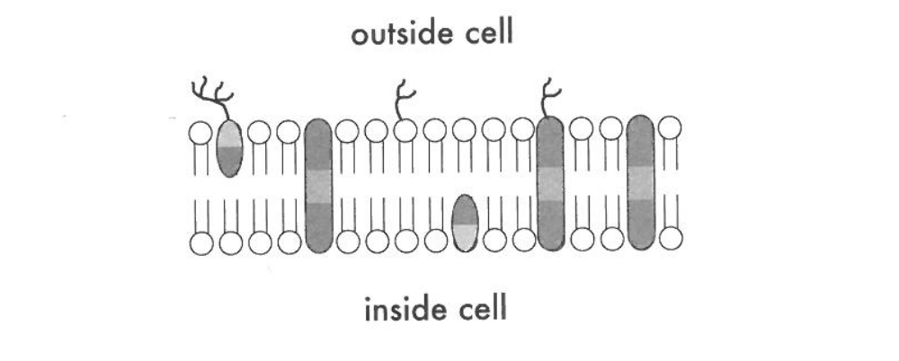
A
B
C

D
E

F

- Which molecule may function in facilitated diffusion?

- A
- B
- D
- E

- Which molecule is both hydrophobic and hydrophilic and aggregates as a bilayer to form the “fabric” of the membrane?

- C
- D
- E
- F

- Which of the following lists has an anabolic process followed by a catabolic process?

 | Anabolic process | Catabolic process
a) | Respiration | Protein synthesis
b) | Protein synthesis | Fat digestion
c) | Anaerobic respiration | DNA replication
d) | Anaerobic respiration | Aerobic respiration

- At high temperatures, the rate of enzyme action decreases because the increased heat:

- Changes the pH of the system
- Alters the active site of the enzyme
- Neutralizes the acids and bases in the system
- Increases the concentration of the enzyme

- Any substance that is acted upon by and enzyme is called a(n):

- Coenzyme
- Vitamin
- Substrate
- Polypeptide

- An enzyme that hydrolyses protein will not act upon starch. This fact is an indication that enzymes are:

- Analytic
- Catalytic
- Synthetic
- Specific

PART B: Short answer questions (20 marks)

The diagram below illustrates two processes carried out by a cell.

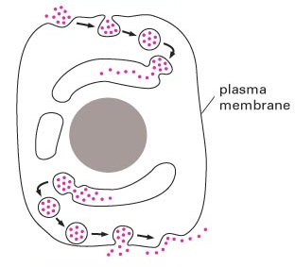
A
B

On your writing paper answer the following :

21. State the names of the two processes A and B illustrated.
(2 marks)

22. Cellular respiration is the process by which glucose is broken down in cells to produce energy that may be stored in adenosine triphosphate (ATP).

- Compare the TWO types of cellular respiration using a properly constructed table, including the reactants, where these processes occur, any waste substances produced and the relative amounts of energy produced.
(8 marks)
- Write the chemical equation that shows the process of cellular respiration.
(2 marks)

23. ATP is an energy carrying molecule.
- What characteristics make it ideal for this role?
(1 mark)
- Explain how it is formed.
(2 marks)
- What is the difference in ATP production in the muscles of a sprinter and a marathon runner?
(2 marks)

24. A semi-permeable membrane allows materials to be transported through it in several ways.
- What is the difference between passive and active transport?
(1 mark)
- Describe one example of each
(2 marks)

